**ETL DESIGN**

**CONTROL FLOW OF DIMENSION AND FACT TABLES**

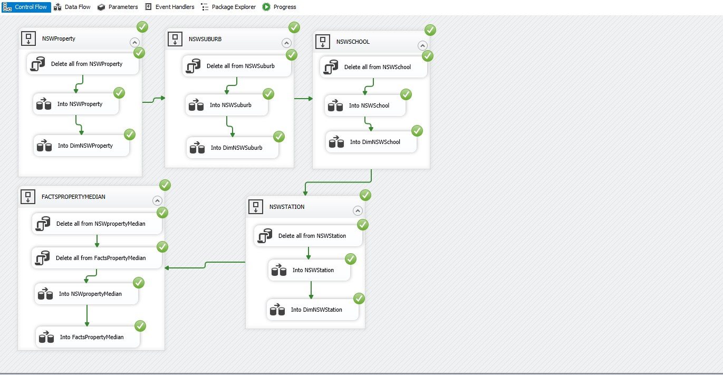

**DATA FLOW OF DIMENSION DIMNSWPROPERTY**

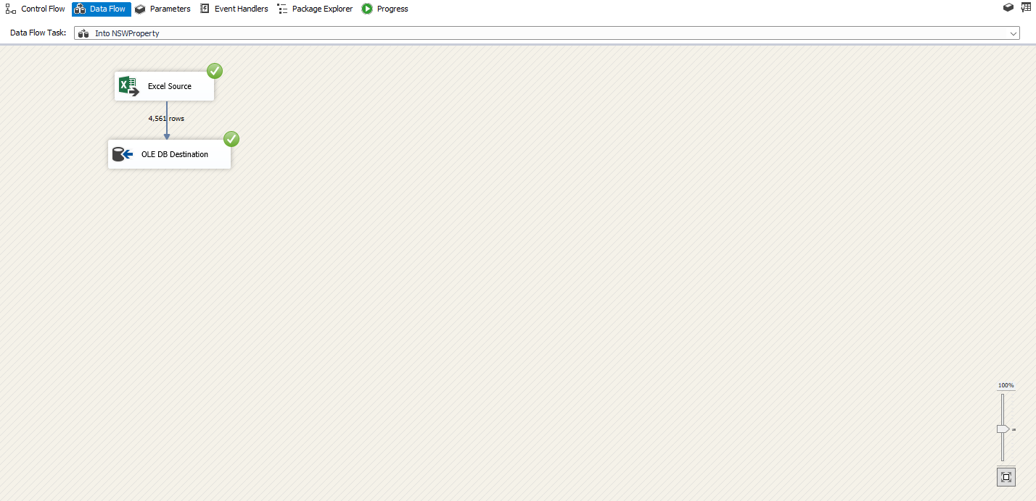

**DATA FLOW OF DIMENSION DIMNSWSUBURB**

**DATA FLOW OF DIMENSION DIMNSWSCHOOL**

**DATA FLOW OF DIMENSION DIMNSWSTATION**

**DATA FLOW OF FACT TABLE FACTSPROPERTYMEDIAN**

**SAMPLE OUTPUT OF FACT TABLE IN SSMS**

